Strategic and Operational roles of Procurement
  - Case Analysis of Sainsbury

Executive Summary
In the modern-day environment where business organisations are subjected to challenges that add to organisational dynamism it is important for companies to design supply chain that are effective and efficient. One of the most significant aspects of supply chain is the procurement strategy that deals with availing products and services from the vendors so that the same can be supplied to the end consumers. The primary intention of this study is to analyse the prevailing procument strategies as adopted by Sainsbury. Sainsbury is one of the largest supermarket retailers in the UK holding a second position after Tesco in the UK. Though the company has a history of more than 150 years but yet in recent times it has taken significant steps to overhaul itself and thus enhance operational efficiency. The overall changes in changes within the organisation has been done keeping sustainability as a primary objective. Owing to the changes the company has been able to progress beyond leaps and bounds and thus register a positive growth irrespective of odds. Considering the achievement made by the company it is considered to be an ideal choice to conduct the study.
From the study, it has been determined that the company has been making efforts incessantly to deal with issues like food wastages, technological changes, operational efficiency, and enhancing supplier relationships. The outcomes have been positive and the company has been stepping towards achievement of sustainability objectives. However, with Brexit, the growth rates as well as pace to achieve sustainability objectives of Sainsbury has been negatively affected. To deal with these issues the company is designing innovative approaches and thus enhancing its procurement management strategies.
Overall, the performance of Sainsbury with regards to procurement strategy has been positive and efficient. Nevertheless, considering the competitive pressure it is important for the company to further enhance its procurement strategies thereby supporting holistic operational efficacy. In order to do so it has been recommended that companies should pursue information sharing and investment in technological advancements.

Background
The company named Sainsbury Plc has been headquartered in London where it first initiated its operations. The company was established in the year 1869 under the leadership of John James Sainsbury (Bloomberg, 2018). From humble beginnings in London, today the company has marked a global presence (Bloomberg, 2018). Though the company started by offering grocery products to its target consumers, but with due passage of time it expanded its product and service portfolio with other items of general merchandise like clothing, financial services and property investments. In order to meet consumer demands, Sainsbury operates through multi-retailing channels which is a combination of physical stores and virtual stores (Sainsbury Plc, 2018). Physical stores are categorized under two kinds namely, supermarkets and convenience stores. The online market place support e-commerce activities of the company thus ensuring that the consumers have an access 24*7. At present the company has a network of 605 supermarkets and 809 convenience stores. Along with them in order to cater to the increasing needs for technology and related services, Sainsbury added stores named as Argos Digital, Habitat stores and Digital Collection (Bloomberg, 2018).

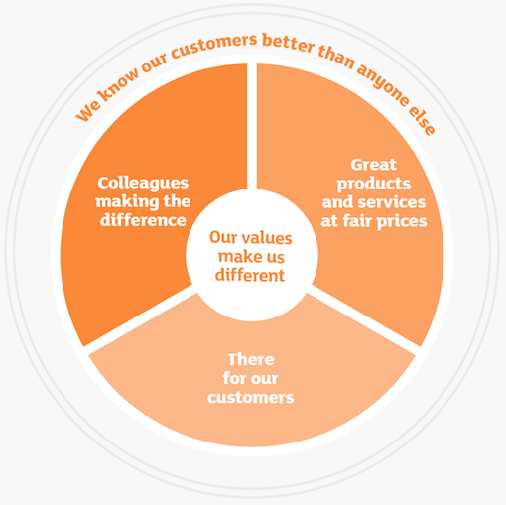
Figure 1 Value System of Sainsbury
Source: (Sainsbury Plc, 2018)
The total spending on procurement by Sainsbury amounts to approximately 3 billion GBP (State of Flux, 2017). The company operates with a base of around 2,000 vendors who are responsible for meeting consumer needs by providing products and services to Sainsbury on a timely basis as per specified requirements (State of Flux, 2017). These vendors are responsible for supporting the company to offer its customers with a product portfolio of 30,000 products to 22 million consumers on a weekly basis. The vendors at Sainsbury are managed through the unique Sainsbury’s Supplier Relationship Management (SRM) strategy. This strategy revolves around consumers and the company expects to integrate supplier and consumers within the business strategy in order to generate escalated benefits for all its stakeholders.

Application and Analysis
Sainsbury as an organization primary deals in two types of products, that are perishable and non-non-perishable ones which has been further categorized as food and non-food products respectively (Sainsbury Plc, 2018). It is important for the company to identify such groups in order to frame its supply chain policies especially those related to procurement. For the food products it is important for Sainsbury to have a procurement mechanism that is swift thereby ensuring that the products are not spoilt and reach its customers in a fresh form. Food products being perishable items are vulnerable and can be spoilt easily if not handled in an appropriate manner within defined time schedules (Wisner & Stanley, 2007). The procurement process needs to be efficient so that products can be availed in a timely manner from the multiple suppliers thus meeting the varied objectives of multiple stakeholders.
The competitive pressure on companies like Sainsbury is increasing at an accelerating rate which is forcing them to resort to innovative approaches and strategies thus sustaining their market share in the long run. The business environment in which contemporary business organizations operate are highly dynamic making it important for the companies like Sainsbury to differentiate themselves from others. Sustainability is one such innovative strategic approach that companies like Sainsbury in recent times are resorting to for differentiating themselves (Giunipero, et al., 2012). This sustainability is adopted in different aspects of a business including procurement. Sustainability approach as adopted by companies is a holistic program which has an impact on various organisational facets. Sustainability is ingrained within an organisation thereby ensuring that each and every function of the company is making efforts to meet organisational vision in the international arena.
A company is prompted by multiple forces to adopt sustainability within its supply chain strategies primarily those related to procurement. This has been explained through a model developed by Seuring & Müller (2008). The model has been presented below:

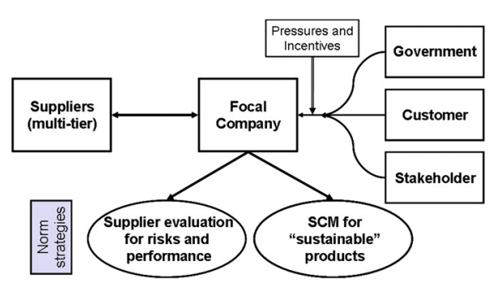
Figure 2 Sustainability and Supply Chain Management (procurement)
Source: (Seuring & Müller, 2008)
This model outlines the relationship between external environment and internal environment that influences the procurement strategy and relationship of a company like Sainsbury with its suppliers with regards to sustainability. As identified from the above model, not only do the stakeholders pressurize a company to resort to sustainable practices in procurement but it is also the culture of the organisation that determines the extent to which it would adopt sustainable practices. Though initially a company adopts sustainable procurement practices under the burden of its stakeholders but eventually it becomes a part of organisational philosophy which has been the fact for Sainsbury.
For meeting the growing needs of its stakeholders and enhancing supply chain efficiency, it resorted to a procurement mechanism and supply chain designed on principles of centralization. Sainsbury adopted the Value Chain Initiative (VCI) with the primary intention to manage its logistics on principles of centralization (Basu & Wright, 2010). However, this approach was a complete failure resulting in huge financial setbacks for the company followed by a downfall in its reputation and loss of market share. However, for overcoming its lost position and market share, the company took decisions for renovating the overall supply chain including the procurement systems through reformatory mechanisms with the intention to meet stakeholder objectives as well as enhancing supply chain efficiency. The new approach ensured that the products and services were smoothly procured, processed and delivered to the end consumers. The renovated procurement and supply chain system was guided under the belief of ‘All or Nothing’. It was this principle that laid the foundation of its vision titles ’20 by 20’ which has been based on long term sustainability (Zentes, et al., 2012).
Organisational supply chain is a process rather a model that establishes connection between all the stakeholder of the company who are involved in ensuring that the products and services are made available to the target consumers thereby filling the gap between demand and supply. The primary stakeholders in a supply chain are suppliers of raw materials and other products, the company itself, the distribution channels and the end consumers. However, it is not as simple as it sounds mainly owing to the fact that at each layer multiple members are associated with the supply chain thus making it intricate and complicated. Considering this intricacy within the supply chain it is important for the companies to ensure that the supply chain is not only effective to generate financial benefits but also resorts to responsible behavior towards other stakeholders like environment and community. The relationship between sustainability and other parameters namely, society, environment and financial benefits has been explained in the diagram below:

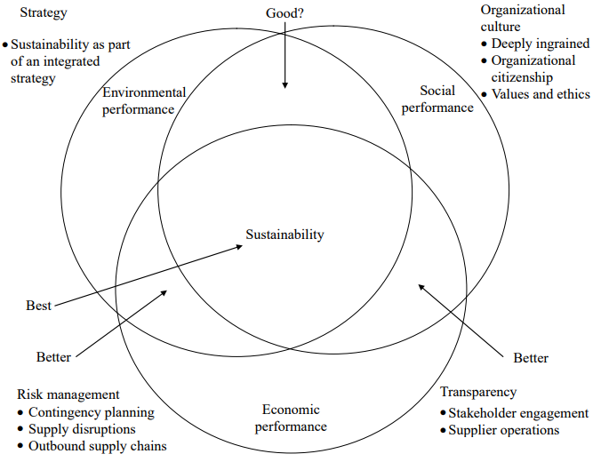
Figure 3 Sustainable supply chain
Source: (Carter & Liane Easton, 2011)
In the case of Sainsbury, it is important to comprehend the role played by sustainability primarily because the overall procurement and purchasing approach of the company is based on the same. As a matter of fact, resorting to such practices has been one of the major differentiating aspects of the company. While competitor companies have been resorting to low-cost strategy, Sainsbury indulges in sustainability of products and services provided to consumers. In order to achieve this, Sainsbury has a dedicated 20x20 sustainability strategy which has been developed on 5 major pillars. The same has been highlighted in diagram below:
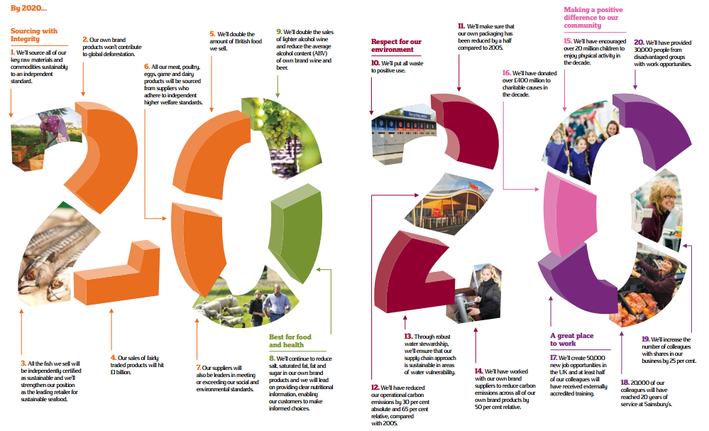
Figure 4 Sainsbury's 20 by 20 Sustainability Plan
Source: (Sainsbury Plc, 2011)
As evident from the diagram above, one of the pillars within this program is “Sourcing with Sustainability”. This approach has shaped the overall purchasing and procurement policy of the company. The acceptance of such sustainable practices by Sainsbury and its embeddedness within the organisational culture is significantly important in modern times. It is mainly because when Sainsbury entered the supermarket industry, it was characterised by factors like
debasement and pollution of products (State of Flux, 2017). Thus, in order to deal with these issues, the organisation design policies to ensure that its procurements are not polluted and it supports sustainability in the long run. The need of sustainable practices has also been acknowledged to be one of the powerful measures of gaining competitive edge within the industry as it assists an organisation to emerge as a leader (Barney, 2012). This has been considered true in the case of Sainsbury as irrespective of competitive pressure from low-cost service providers like Tesco, it has been maintaining its position within the top 4 supermarket retailer companies in the UK.
Most of the companies do not resort to sustainability owing to the fact that it adds to the costs. However, they fail to realise that with added costs these companies are endowed with added benefits not financial and non-financial in nature. With sustainable sourcing, Sainsbury has been able to multiply its sales by twofold in Britain. This has been possible by achievement of milestones like, ploughing investments of approximately 1 million GBP in farming in Britain. Further, the company has revamped it supply chain to procure 100% fresh British pork since year 2013 (Lockhart, 2014). Sainsbury uses British meat for all the ready-to-eat meals and pies that are freshly made. Since, 100 year now, Sainsbury has been extending its support to the potato farmers even during the rainiest seasons (Lockhart, 2014). Since 2010 till 2014, Sainsbury has been ranked at the top position for being the largest retailer within the UK primarily for British apples and pears (Lockhart, 2014).
Though it seems to be easy but adoption of sustainability within the procurement policies is challenging as there are multiple hurdles that an organisation needs to deal with. Even Sainsbury has been subjected to a series of issues like declining profitability and inability to cater the challenging markets in an effective manner owing to increased risks and costs (Rodionova, 2017). Owing to Brexit that has resulted in the separation of the UK from the European Union (EU), the procurement strategies of Sainsbury have been equally affected like the marketing ones. It is mainly because the company has to overhaul its existing supply chain based on new policies and regulations that would be effective post Brexit. In such a scenario, Sainsbury would continue to experience increased costs with limited marketability. Yet the company has been dedicated towards sustainable procurement and achievement of its long-term vision of Sourcing with Integrity (Rodionova, 2017). Such sudden changes within the economy owing to Brexit, the company has been subjected to issues in supply chain disruptions (Reuters, 2017). These are outcomes of delays in procurements resulting in delay in supply to ultimate consumers owing to increased custom checks. In the due process, the perishable products are becoming stale and thus a huge amount of wastage is generated (Reuters, 2017). The outcome is ineffective supply chain and enhanced organisational costs which ultimately is having a negative impact on Sainsbury’s goodwill.
Another element of procurement strategy of Sainsbury is adoption of technological advancement. Adoption of new technologies supported Sainsbury to bring about revolutionary changes within its approach to business as a whole. Such changes and technologies assisted the company to deal with competitive pressure thereby progressing against all odds. The various aspects of the procurement and supply chain in Sainsbury were explored, organized, coordinated and controlled with the help of new technologies thus enhancing its overall efficiency (Luo, 2013).
To support its overall supply chain and as a part of sustainability approach, Sainsbury resorted to the strategy of “From Farm to Fork” as shown in diagram below:

Figure 5 Sainsbury's Approach to "From Farm to Fork"
Source: (Sainsbury Plc, 2011)

As a part of technology advancement, the suppliers of Sainsbury are encouraged to communicate and share information with the help of internet. This assists the company and the suppliers to take decision swiftly which ultimately results in enhancement of operational efficacy of the company. Even being linked to GlobalNet Xchange (GNX), Sainsbury has been in a position to avail information which assists the company to deal with problems and issues in an effective manner (Rajput, 2011).
For enhancing procurement and supply chain efficiencies, Sainsbury also espoused to Paragon Software Systems (Paragon, 2009). The primary objective behind this was to resolve scheduling issues hereby optimizing both inbound and outbound logistics. In order to manage the scheduling mechanism of Sainsbury, the company adopted tracking mechanism by Isotrak. Both these systems though failed to meet the desired objectives especially those related to management of traffic problems and unanticipated events. Yet both were considered to support Sainsbury in enhancing its efficiency related to procurement and supply chain. To overcome the issues and failures experienced by Sainsbury irrespective of adopting modern technologies, the company ultimately developed the Integrated Transport Management System (ITMS). This system was developed in association with Paragon and Isotrak (IGD, 2010). Some of the primary objectives of this system was to reduce costs, enhance operational and procurement efficiency, minimising the running of vehicles that were vacant and pursue enhanced fuel savings. The system also intended to optimize the travelling in terms of mileage as well as minimize carbon footprint. The outcome of this system was positive as the company was able to achieve major milestones and today has emerged as powerful company that is sustainable in its approach (IGD, 2010; Sainsbury Plc, 2011).

Recommendations
Though the company has been resorting to mechanisms to enhance overall procurement and purchasing efficiency but there are still avenues for development. Based on analysis the following approaches are being recommended:
- Information Sharing: In order to enhance operational efficacies, it is important for the company to share information within the supply chain thus making the procurement process more transparent and raising consumer confidence. With sharing of information, Sainsbury will also enhance the confidence of its stakeholders thus motivating them to take interests in organisational functioning. Also, this will encourage them to participate actively by putting forward their suggestions and guidance for holistic improvement of the supply chain. This would result in enhanced effectiveness of organisational operations. With the help of information sharing, the company will also be in a position to take dedicated approaches thus behaving in a responsible manner. Sainsbury will also be able to optimize allocation of resources based on this information sharing and knowledge sharing. This will also help the company to pursue a transparent relationship with the government as well as other legal authorities. A clear information sharing will also provide the suppliers with the regulatory framework that they would have to resort to in order to be a part of Sainsbury.
- Technology Advancement: With technological advancement, Sainsbury will be in a position to gain competitive edge within the industry. these technology advancements would be related to sustainability thus helping the company to embed this strategic approach within its culture. For undertaking technological advancements, Sainsbury needs to invest in research and technology thus being innovative in its approach.

For adopting these recommended approaches, Sainsbury needs to pursue procedural and systematic investments. These investments can be done by keeping reserve funds. Also, ties up with research universities and colleges will help the company to design innovative approaches that can be implemented in practical environment.

